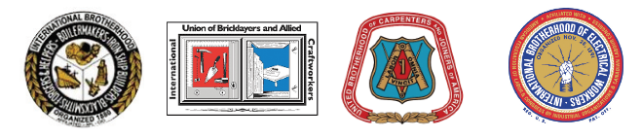Boston Building Trades

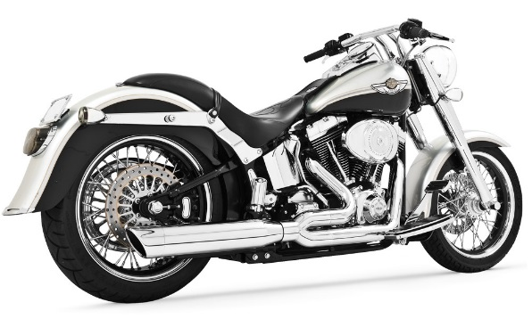2017 Helmet to Hardhats Motorcycle Run

Proceeds raised will be donated to

Local 17’s Paul Briggette

September 23, 2017

Rally point:

LOCAL 17 JATC 1181 Adams St. Dorchester, MA 02124

The bike route to go by Local 17 Steve Sennett’s home on Dyer St. Whitman, MA.

The ride to conclude at Canton Town Club @ 244 Bailey St. Canton, MA

Registrations @ 9:00 AM

Kickstands up @ 10:15 AM



*$25 per Bike*

*$10 per Passenger*

*Food ♦ Music ♦ Raffles*

♦ ***DONATIONS*** ♦

Make Checks payable to:

SMW Local 17

1157 Adams Street

Dorchester, MA 02124

Please call Richie Eckler with any questions: (781)956-2534